Remove all packages of jasmine karma before executing jest: npx jest

"@types/jasmine": "~5.1.0",

"jasmine-core": "~5.1.0",

both **TestBed** and **render** from @testing-library/angular in the same test file.

These two approaches **conflict** because **TestBed** initializes the Angular testing module, while **render** creates its own independent instance of the component.

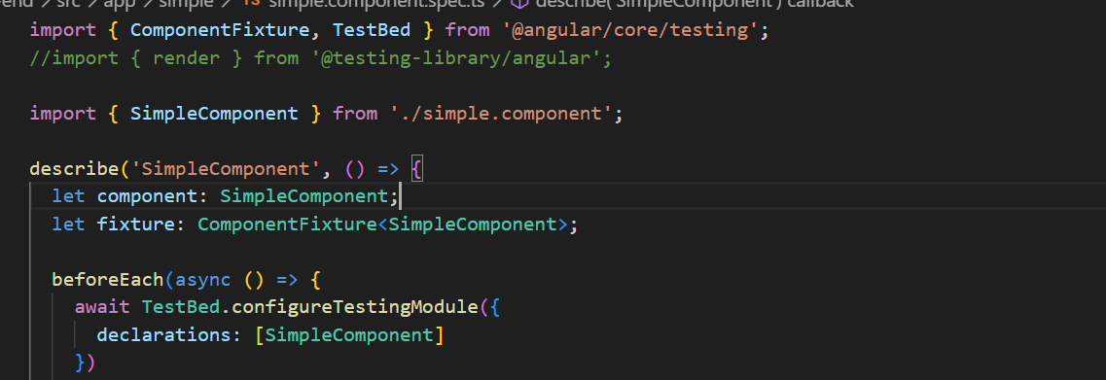

Use either:

1. **TestBed (traditional Angular testing)**
2. **@testing-library/angular (preferred for snapshot testing)**

**Solution 1: Remove TestBed and Use render for Snapshot Testing**

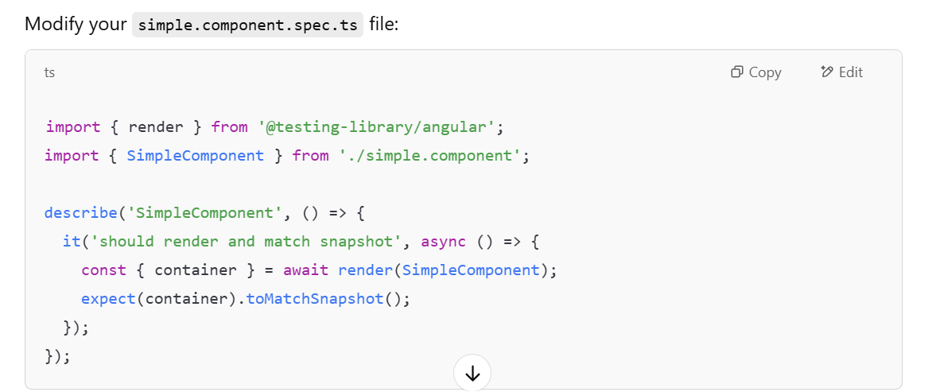

**Why this works?**

* render(SimpleComponent) renders the component in isolation without using TestBed.
* It avoids the conflict caused by TestBed.configureTestingModule being instantiated twice.

Solution 2: Use Only TestBed (Without render)

If you still want to use TestBed, you must remove render and manually capture the component's HTML for snapshot testing:

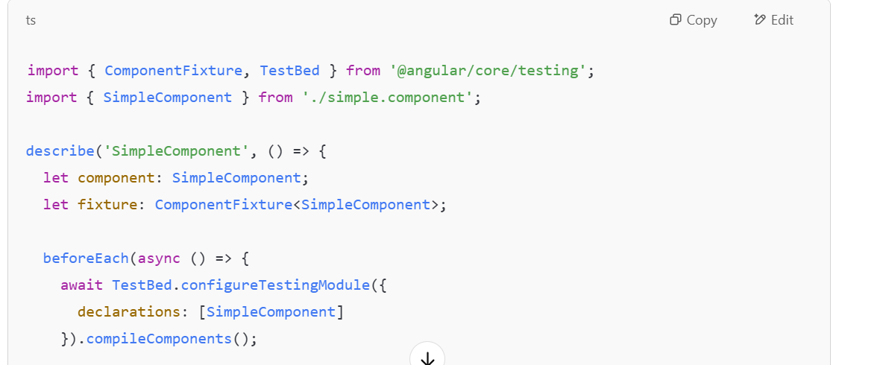 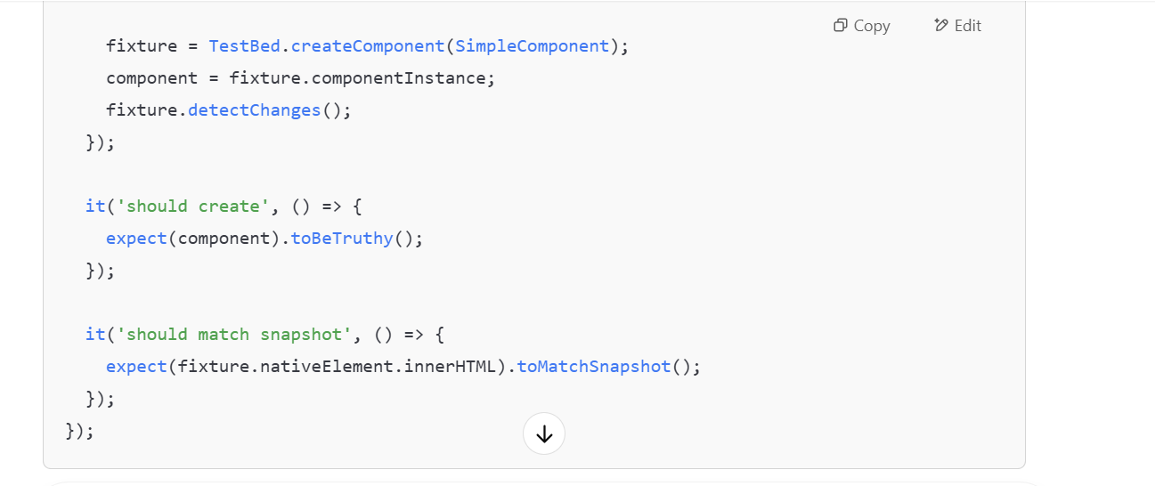 **Key Differences**

* Solution 1 (render): Preferred for snapshot testing with @testing-library/angular.
* Solution 2 (TestBed): Works without render, manually extracts HTML for snapshot comparison.

When writing standard unit tests (like toBeDefined, toEqual, etc.), we typically use **TestBed**. Adding render from @testing-library/angular in the same file will create unnecessary conflicts because render initializes its own test environment, separate from **TestBed**.

**Best Practice for Combining Snapshot Testing with TestBed**

If you want to keep **TestBed** for regular unit tests and still include snapshot testing in the same file, the recommended approach is:

Use **TestBed** for usual test cases.

Avoid using render in the same file.

Extract the component’s HTML manually and match it to a snapshot.

**Why This Approach?**

✅ **Avoids conflicts** – No mixing of render and TestBed.  
✅ **Uses TestBed for all tests** – Consistent setup for regular and snapshot tests.  
✅ **Manually extracts HTML** – Ensures snapshot testing without unnecessary test environments.

